Budget Status — Deep Test Review
06 September 2026 · Round 4 · Local fixes validated against real read-only data and synthetic edge cases. Confirmed fixes deployed as GL 1.116.1; the print-permission policy remains unchanged pending the user decision.
Suite | Passed / tested
Live baseline browser | 190 / 190
Live baseline reports | 51 / 51
Fixed UI regression | 190 / 190
Show Summary | 66 / 66
Deep browser | 40 / 40
Export formatting and pagination | 85 / 85
PDF and PPT artifacts | 24 / 24
Account access | 7 / 10
Deployed browser | 190 / 190
Deployed Show Summary | 67 / 67
Deployed reports | 51 / 51
Deployed deep browser | 40 / 40
Entity exports | 11 / 11
Additionally: live API baseline 144/144 assertions; report unit regression 4/4 tests. Baseline results describe the deployed version before these fixes. Fixed-UI and export results describe validated local changes; deployed suites repeat the key checks on GL 1.116.1.

Confirmed fixes
- Saved JSON null and unavailable browser storage no longer break Budget Status controls.
- Older responses and failures cannot replace the newest request; choosing a valid cached period clears the old error and invalidates pending requests.
- Search supports Enter/Space, criteria have accessible names, Entity buttons expose selection, and hover instructions follow Show Summary.
- Collapsed Search displays configured Entity names; the report bridge now validates against configured active Entity values (SQL deployed; six regular exports passed; all-entity export results are recorded separately).
- PDF/PPT numeric formatting matches dashboard rounding and automatic units. Long entries move intact onto continuation pages; actual page numbers are recalculated.
- User-approved behavior: all-zero-budget sectors/departments show Ledger rows with No budget allocated, including report output. Show Summary remains effective in the fallback.

Decision required
The GL compatibility setting allows signed-in users without GL_RUN_BRIEFING_BOOK to queue reports. Cross-user report status and downloads return 404, including for another privileged user. Three strict-403 expectations therefore remain marked DECISION; this is not evidence of cross-user access. The user must choose whether Budget Status should require the dedicated print privilege or retain compatibility behavior. Temporary accounts and sessions were removed; cleanup logs are attached.
The user explicitly authorized the built-in quick login after automatic approval review initially blocked the additional entity test. It was then run with that authorization; its results appear in the Entity exports suite. Deployed report SQL compiled successfully; the normal six-export regression passed.

Suggested enhancements — not implemented
- Executive exceptions: a short list of the sectors/departments with the lowest remaining funds or negative balances, with direct drill-through. Example: Capex — 3% remaining.
- Data freshness: show the accounting period and last successful data refresh beside the total so executives can judge how current the figures are.
- Visible filter chips: keep Entity, selected Sectors and Departments visible above results, with an individual clear action to make scope easier to understand.

Evidence

Approved zero-budget fallback
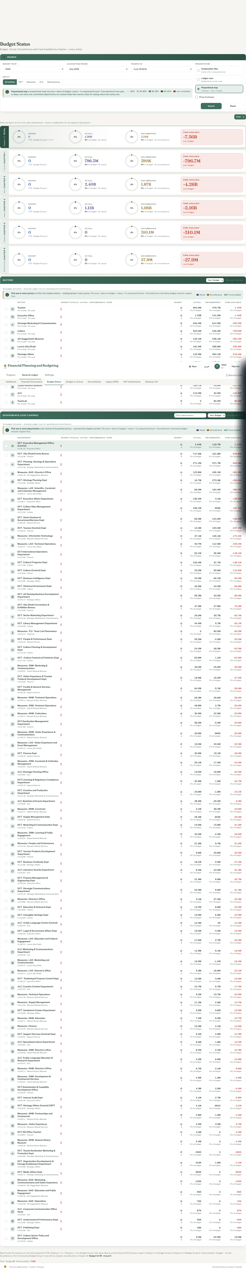

English PDF sample
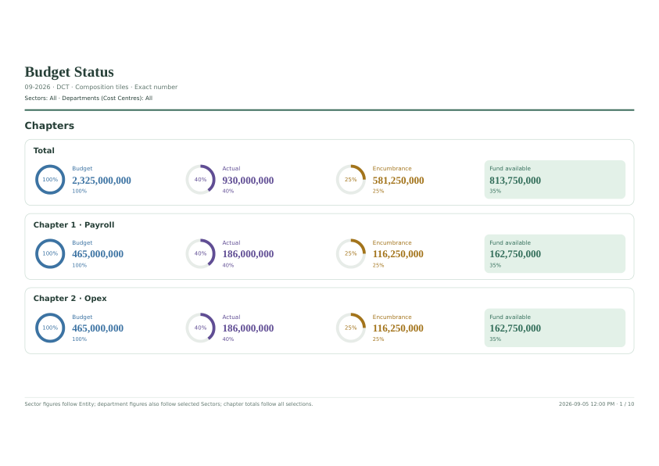

Arabic PDF sample
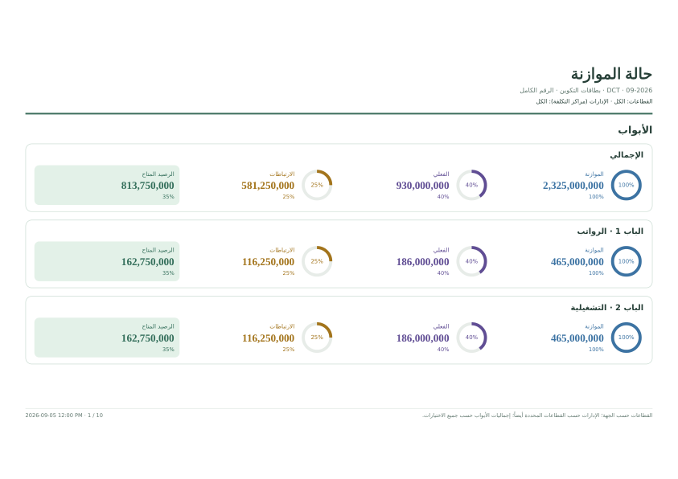
Artifacts include 12 PDF/PPT files covering all three layouts in both languages, before/after edge results, live report samples, browser screenshots and account-cleanup logs. Production financial data is present in baseline evidence. No emails or messages were sent.

